Information about property intended for sale.
«Agrarian Credit Corporation» JSC carries out the sale of property accepted on the balance sheet through an auction for price increase/decrease and direct sales according to the list:
№  p/n | Name | Brief characteristics | Location | Photo of the object
 | Reconstruction of two cowsheds for procurement points for the procurement of livestock and livestock products with export infrastructure (includes pump ECV-6-10-80; control station SUZ-40; diesel power station) | Warehouse and garage with a total area of ​​220.6 sq. m. meters; Sheepfolds with a total area of ​​1413 sq. meters; Quarantine premises with a total area of ​​1198.8 square meters. meters; ABC with a total area of ​​208.7 sq. meters; Pumping room with a total area of ​​10.2 sq. meters; Land site 39.0011 ha. | Aktobe region, Mugalzhar district, Sagashili village, st. S. Baishev, building 30 | 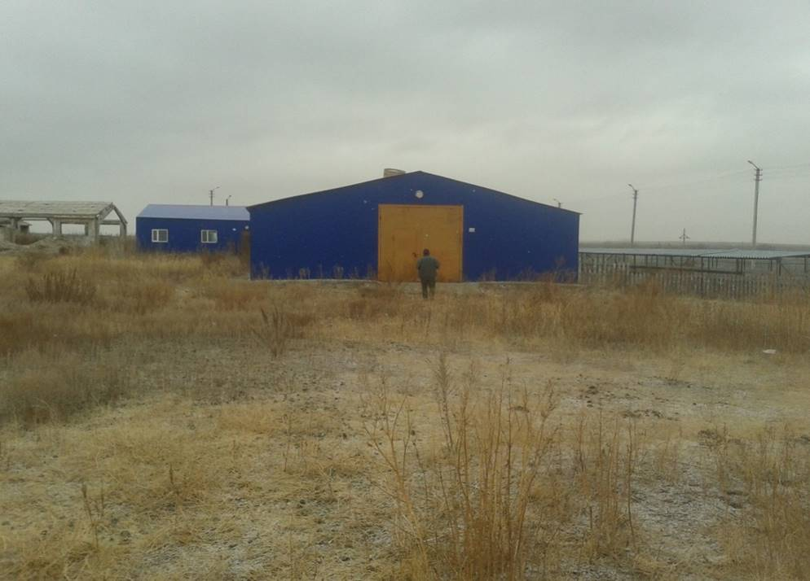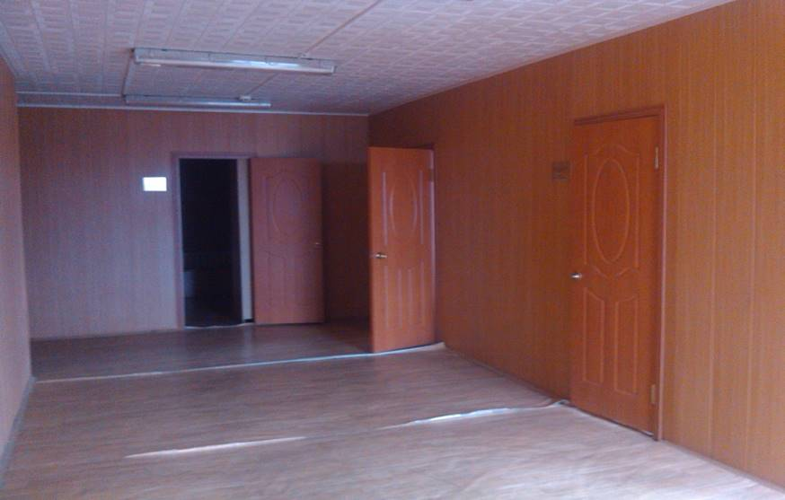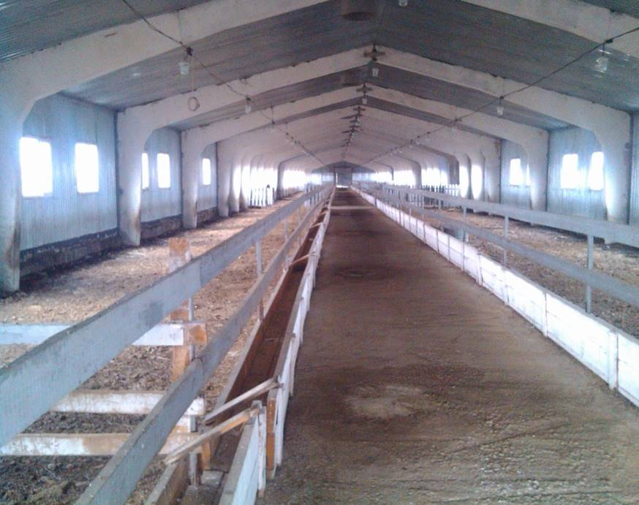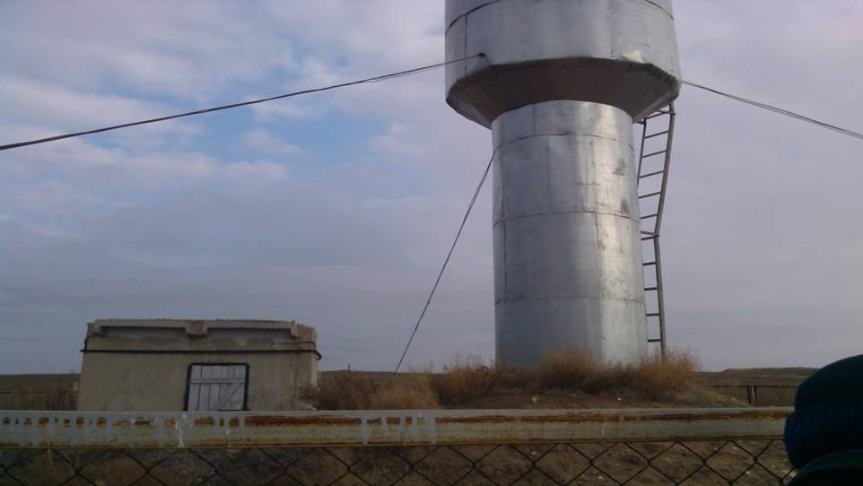
 | Office space | Total area 119.5 sq. meters with a land site in common shared ownership of 0.0071 ha. | EKR, Ust-Kamenogorsk city, Satpayev Ave., 62 | 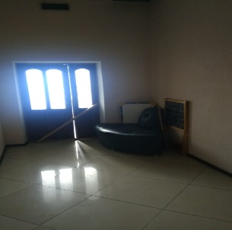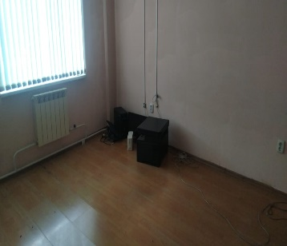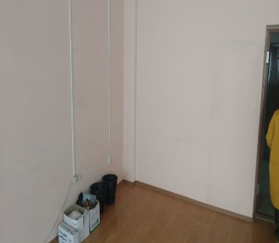
 | Office space | The total area of ​​the premises 557.3 sq.m., the land site 1.5302 ha, including a share of 0.0229 ha. Cadastral number of the land site No. 20:315:012:302 | Almaty, Medeu district, st. Kabanbai batyr, building 51/78, n.l.b. 65 | 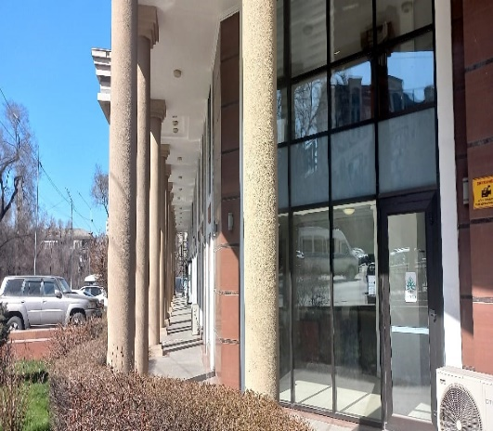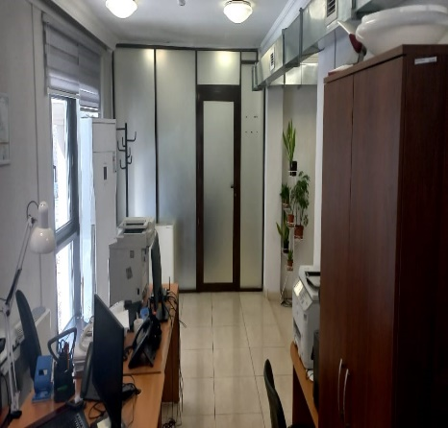
 | Residential building | The total area of ​​the Residential building 308 sq.m., including a living area of ​​166.6 sq.m., with a land site of 0.0321 ha. Cadastral No. 12:193:010:808 | Kostanay region, Kostanay city, Baitursynov street, building 140 | 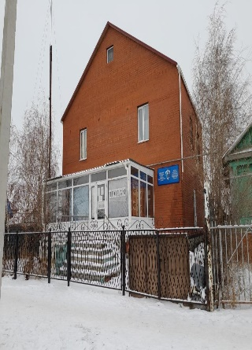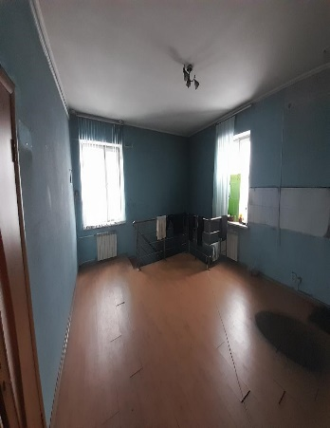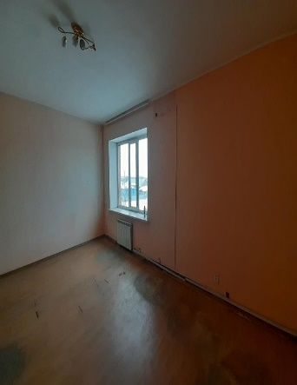
 | A building with printing equipment and a land site of 0.102 (ha) cadastral number 21:319:014:020 | Total area 639.9 sq. meters with equipment | Astana city, Saryarka district, st. Ykylas Dukenuly, building 6 | 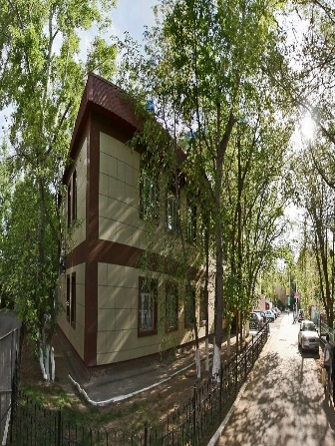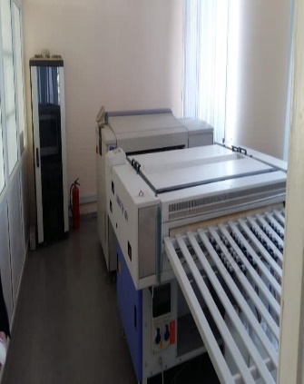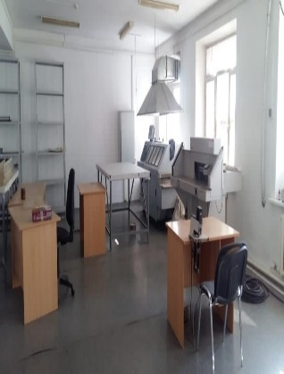
 | Greenhouse complex (without registration of buildings) | Two land sites with areas of 6.76 ha. (on temporary land use rights) and 3.24 ha. (owned).  Cadastral number of the land site No. 06:088:046:380 and cadastral number of the land site No. 06:088:058:472, respectively. | Zhambyl region, Zhambyl district, Karatobe rural district, Baiterek village, Amankeldi TN, site 183* | 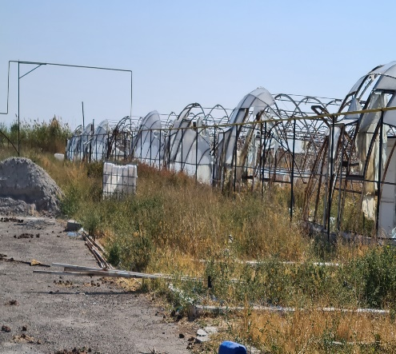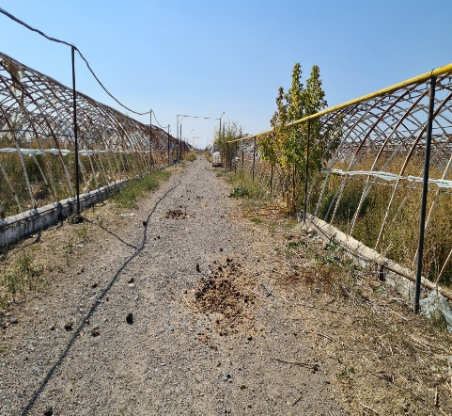
 | Greenhouse complex | The total area of ​​the greenhouse 49,619.67 sq.m. with a land site of 9 ha. Cadastral number of the land site No. 06:088:058:396 | Zhambyl region, Zhambyl district, Karatobe rural district, Baiterek village, Amankeldi TN, site 81* | 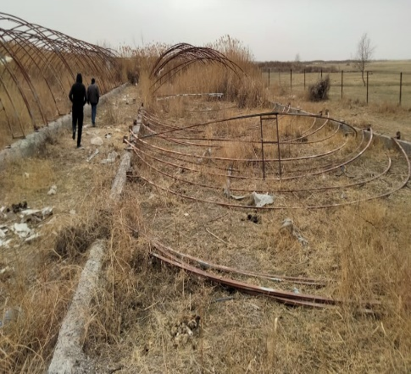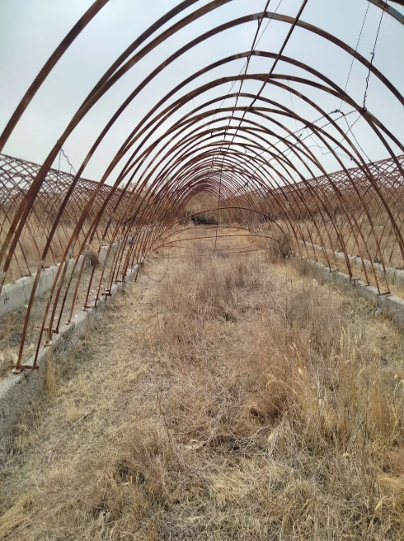
 | Greenhouse complex (without registration of buildings) | Two land sites of 5 ha. each, with temporary land use rights.  Cadastral number of the land site No. 22:327:024:107 and cadastral number of the land site No. 22:327:024:108 | Shymkent, Abay district, Yntymak microdistrict, section 108/1 and 107/1 | 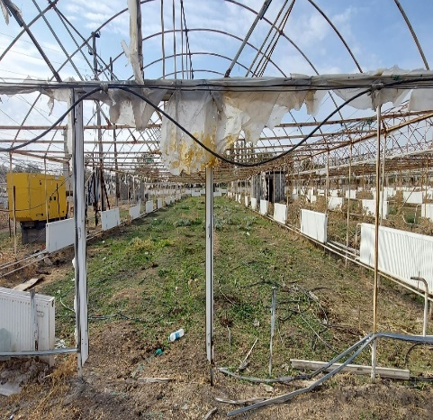
 | Land site | Land site with an area of ​​5 ha., cadastral number (19-309-215-023), divisible site, intended purpose of the site is for farming. | Shymkent city, Karatau district, block 215, block 215,023 | Photo of the land site is not attached
 | Land site | Land site with an area of ​​50. (ha), cadastral number (19:294:048:113), divisible site, intended purpose of the site of land for agricultural purposes | Turkestan region, Otyrar district, Koksarai village, st. Koksarai, block 048 K, site 113 | Photo of the land site is not attached
 | Land site | Land site with a total area of ​​3934 (ha), cadastral number 15:167:016:036, intended purpose of conducting commercial agricultural production at the address: North Kazakhstan region, Akzhar, district. Talshyk village | North Kazakhstan region, Akzhar, district. Talshyk village | 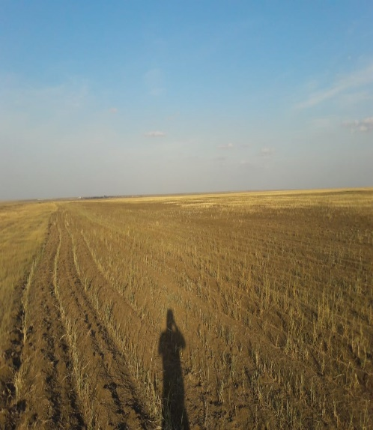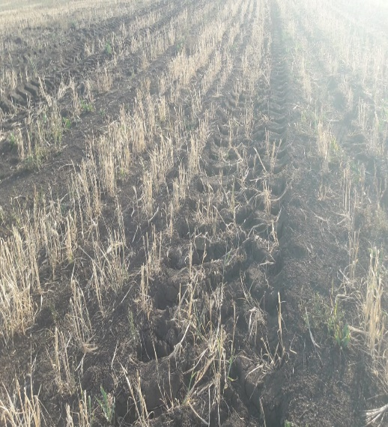
 | Land site | Land site with the right of temporary paid land use, with a total area of ​​33,339 ha., including arable land 11,574 ha., pastures 21,765 ha., cadastral number 01-172-039-017 | Akmola region, Birzhan Sal district, Enbekshilder rural district | Photo of the land site is not attached

For real estate, the Company considers the option of selling it in installments with a down payment.
For all questions, please contact the indicated telephone numbers.

Tlebaldin Murat, telephones: 7 (7172) 55-99-92, ext. 3011; 8 747 485 55 74, email. address Tlebaldin.M@agrocredit.kz
Igisenova Aliya, telephones: 7 (7172) 55-99-61, ext. 3180; 8 707 240 70 82, email. address Igisenova.A@agrocredit.kz

